# Aim:

**CreateUDF(UserDefined Functions)inApachePigandexecuteit in MapReduce/ HDFSmode**

Tocreate UDFinApachePigandexecuteit in MapReduce/HDFSmode.

# Procedure:

**PigDownloadandinstallation:**

1. DownloadPig:

DownloadPigfrom“https://downloads.apache.org/pig/pig-0.17.0/”

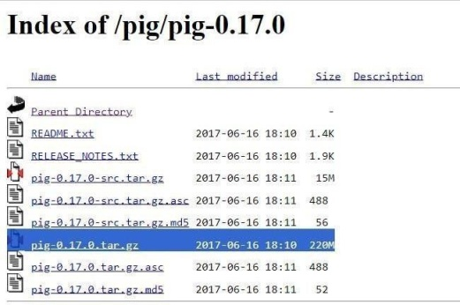

1. Addtheenvironment variableforPig:

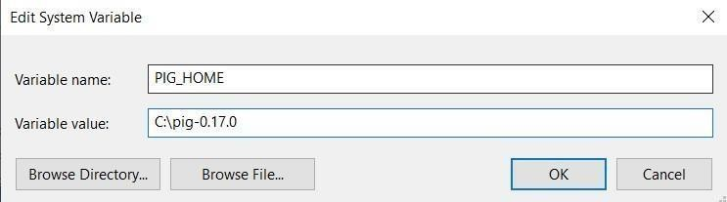

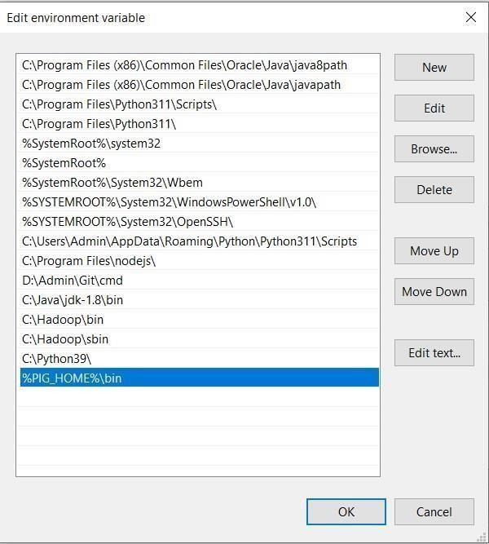

1. GotoC:\pig-0.16.0\binandopenpig(WindowsCommandScript)



1. OpenWindowsPowershell andtype“pig–xlocal”andcheckwhetherpiggruntappears.

# Pigissuccessfullyinstalled.

**CreateUDF:**

# StartHadoopservices:

Opencommandpromptasanadministrator

start-dfs.cmdyarn.cmd

start-

1. 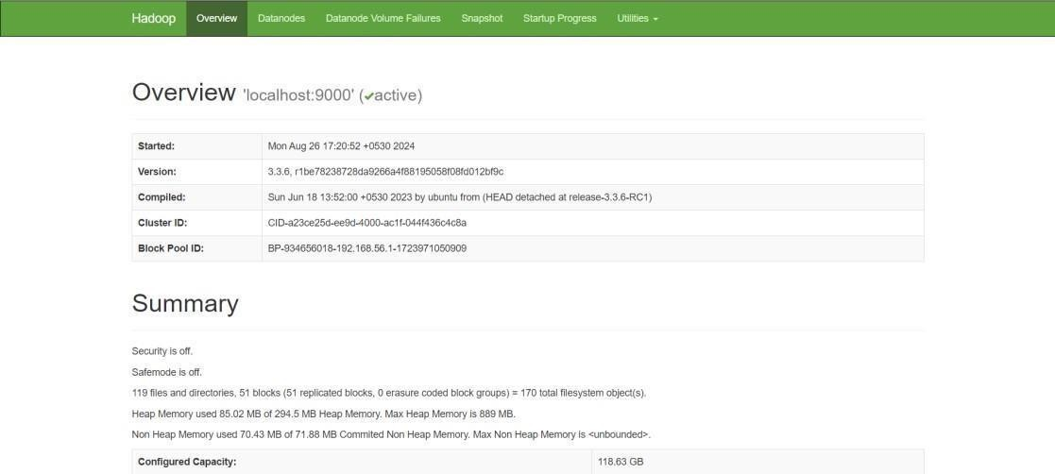Openthebrowserand goto theURL“localhost:9870”
2. Createatextfile“input.txt”:

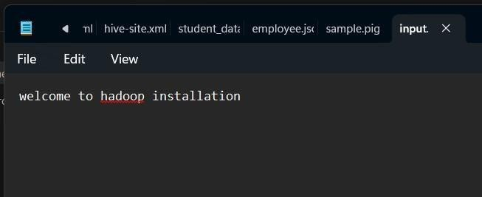

1. 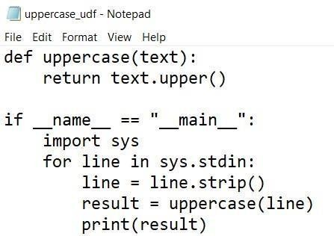CreateaPythonfile“uppercase_udf.py”:

6.CreateaDirectoryinHDFSandcopytheInputFiletoHDFS

Hadoopfs-mkdir/piginput

hadoopfs-putudfsC:\pig\sample.pig /piginput



1. Createpigfile“sample.pig”:

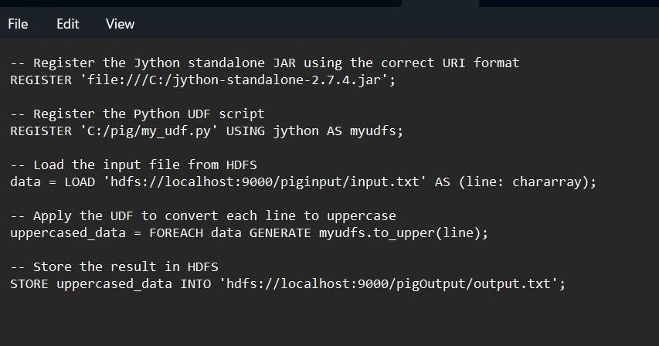

1. ExecutePigfile:

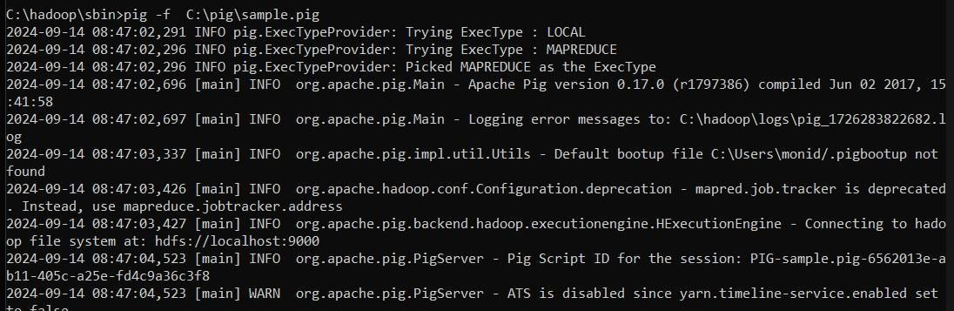pig-fC:\pig\sample.pig

1. ViewtheOutputhdfsdfs-ls/pigOutput

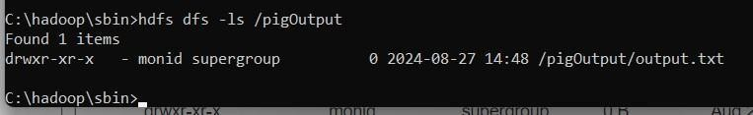

hdfsdfs-cat/pigOutput/output.txt/part-m-00000



1. Oncethemapreduceoperationsareperformedsuccessfully,theoutputwillbepresentinthespecifieddirectory.

“/pigOutput/output.data/part-m-00000”

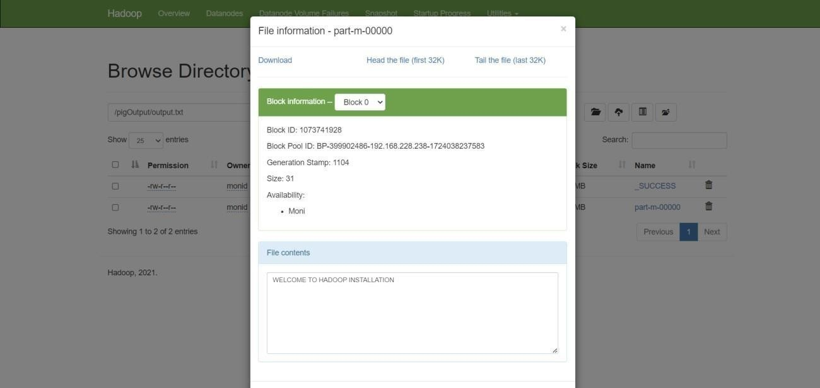

1. StopHadoopServices stop-dfs.cmdstopyarn.cmd

# Result:

Thus,UDFinApachePig hasbeen createdandexecutedin MapReduce/HDFS modesuccessfully.